**Lab 4 assignment**

Name: Yerraballi Suresh Kumar Reddy

USN:19MCAR0080

4MCA

Python Programming Lab

Date: 19/02/2021

**3. Write python programs to perform following tasks:**

**a. Find given number is palindrome or not**

num = input('Enter any number : ')

try:

val = int(num)

if num == str(num)[::-1]:

print('The given number is PALINDROME')

else:

print('The given number is NOT a palindrome')

except ValueError:

print("That's not a valid number, Try Again !")

**Output:**





**b. Print multiplication tables from 2 to given number**

num = int(input("Show the multiplication table of? "))

for i in range(1,11):

print(num,'x',i,'=',num*i)

**output:**

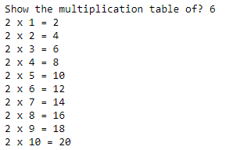

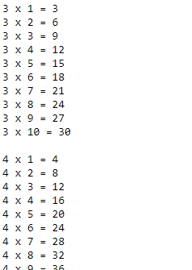

**So on**

**4. Write a python program to find mean, mode and standard deviation of n numbers using list**

n_num = [11, 22, 33, 44, 55]

n = len(n_num)

get_sum = sum(n_num)

mean = get_sum / n

print("Mean / Average is: " + str(mean))

n_num.sort()

if n % 2 == 0:

median1 = n_num[n//2]

median2 = n_num[n//2 - 1]

median = (median1 + median2)/2

else:

median = n_num[n//2]

print("Median is: " + str(median))

**Output:**



from collections import Counter

n_num = [1, 2, 3, 4, 5,5,6,7]

n = len(n_num)

data = Counter(n_num)

get_mode = dict(data)

mode = [k for k, v in get_mode.items() if v == max(list(data.values()))]

if len(mode) == n:

get_mode = "No mode found"

else:

get_mode = "Mode is / are: " + ', '.join(map(str, mode))

print(get_mode)



**5. How many asterisks does the following code fragment print?**

a = 0

while a < 100:

print('*', end='')

print()

**Output:**



**6. How many asterisks does the following code fragment print?**

a = 0

while a > 100:

print('*', end='')

a += 1

print()

**Output:**

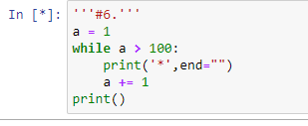

Zero

**7. How many asterisks does the following code fragment print?**

a = 0

while a < 100:

b = 0

while b < 55:

print('*', end='')

b += 1

print()

a += 1

**Output:**

**No output**

**8. How many asterisks does the following code fragment print?**

a = 0

while a < 100:

if a % 5 == 0:

print('*', end='')

a += 1

print()

**Output:**



**9. How many asterisks does the following code fragment print?**

a = 0

while a < 100:

b = 0

while b < 40:

if (a + b) % 2 == 0:

print('*', end='')

b += 1

print()

a += 1

**Output:**

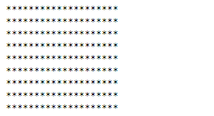

**10. How many asterisks does the following code fragment print?**

a = 0

while a < 100:

b = 0

while b < 100:

c = 0

while c < 100:

print('*', end='')

c += 1

b += 1

a += 1

print()

**Output:**

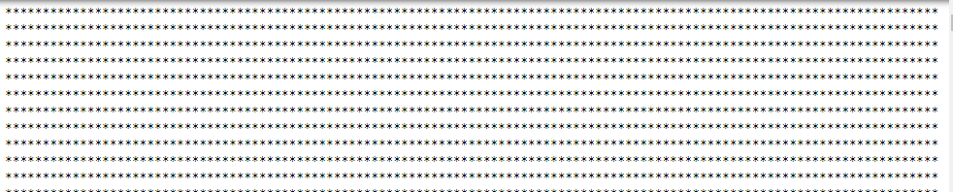

**11. What is minimum number of arguments acceptable to the range expression?**

1

for i in range(1):

print(i)

**Output:**



**12. What is maximum number of arguments acceptable to the range expression?**

**3**

13. Provide the exact sequence of integers specified by each of the following range expressions.

(a) range(5)

**Output:**

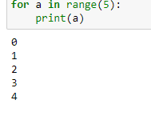

(b) range(5, 10)

**Output:**

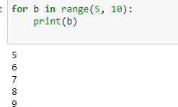

(c) range(5, 20, 3)

**Output:**

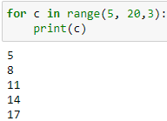

(d) range(20, 5, -1)

**Output:**

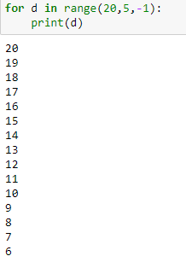

(e) range(20, 5, -3)

**Output:**

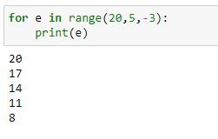

(f) range(10, 5)

**Output:**

No output

(g) range(0)

**Output:**

**No output**

(h) range(10, 101, 10)

**Output:**

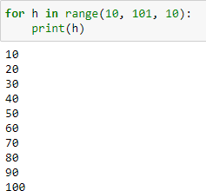

(i) range(10, -1, -1)

**Output:**

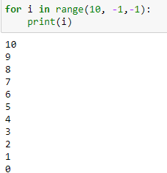

(j) range(-3, 4)

**Output:**

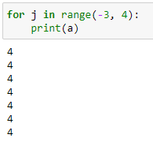

(k) range(0, 10, 1)

**Output:**

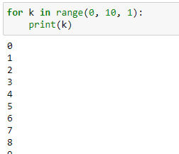

14. What is a shorter way to express range(0, 5, 1)?

**Output:**

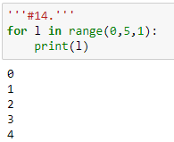

15. Provide an equivalent Python range expression for each of the following integer sequences.

(a) 1,2,3,4,5

**Output:**

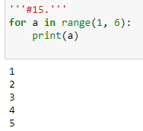

(b) 5,4,3,2,1

**Output:**

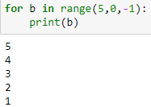

(c) 5,10,15,20,25,30

**Output:**

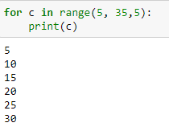

(d) 30,25,20,15,10,5

**Output:**

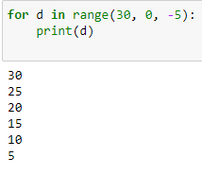

(e) −3,−2,−1,0,1,2,3

**Output:**

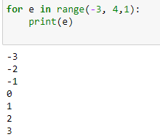

(f) 3,2,1,0,−1,−2,−3

**Output:**

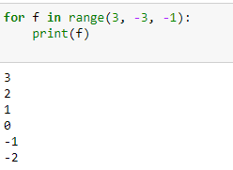

(g) −50,−40,−30,−20,−10

**Output:**

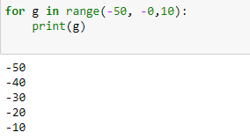

16. If x is bound to the integer value 2, what integer sequence does range(x, 10*x, x) represent?

**Output:**

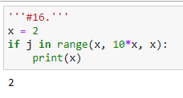

17. If x is bound to the integer value 2 and y is bound to the integer 5, what integer sequence does

range(x, x + y) represent?’

**Output:**

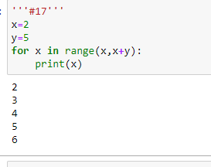

18. Is it possible to represent the following sequence with a Python range expression: 1,−1,2,−2,3,−3,4,−4?

**Output:**

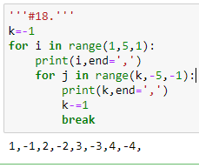

19. How many asterisks does the following code fragment print?

for a in range(100):

print('*', end='')

print()

**Output:**

**100**

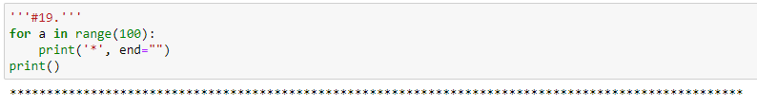

20. How many asterisks does the following code fragment print?

for a in range(20, 100, 5):

print('*', end='')

print()

**Output:**

**16**

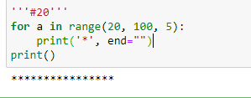

21. How many asterisks does the following code fragment print?

for a in range(100, 0, -2):

print('*', end='')

print()

**Output:**

**50**

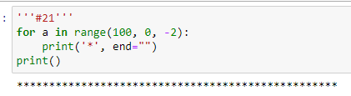

22. How many asterisks does the following code fragment print?

for a in range(1, 1):

print('*', end='')

print()

**Output:**

**None**

23. How many asterisks does the following code fragment print?

for a in range(-100, 100):

print('*', end='')

print()

**Output:**

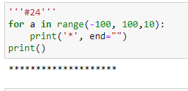

24. How many asterisks does the following code fragment print?

for a in range(-100, 100, 10):

print('*', end='')

print()

**Output:**

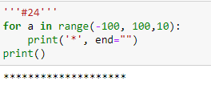

25. Rewrite the code in the previous question so it uses a while instead of a for. Your code should

behave identically.

**Output:**

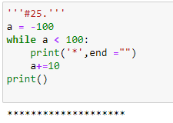

26. What does the following code fragment print?

a = 0

while a < 100:

print(a)

a += 1

print()

**Output:**

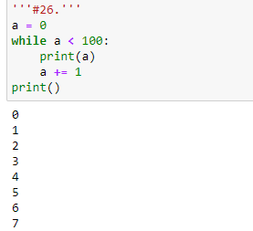

27. Rewrite the code in the previous question so it uses a for instead of a while. Your code should

behave identically.

**Output:**

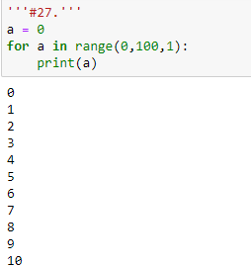

28. What is printed by the following code fragment?

a = 0

while a > 100:

print(a)

a += 1

print()

**Output:**

None